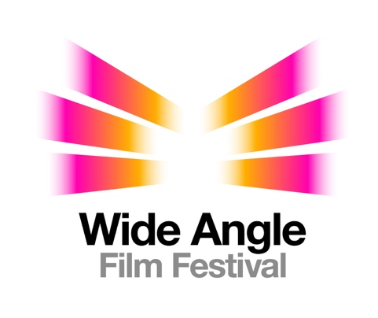

Corporate Program Screening Information

The Bardic Studio is pleased to offer a forty minute program of award winning Australian and international short films, reflecting the lived experience of people with disability, to businesses for screening to staff. Wide Angle Film Festival is offered free of charge, together with marketing collateral to encourage staff participation.

The Corporate Program fits into a lunch break and can be screened as many times as you wish. Screenings can be in lunchrooms, meeting rooms, boardrooms or off-site. We welcome collaborations between two or more organisations so feel free to invite your neighbours if you have the room.

With one in five people in Australia living with disability, it’s important that Australians challenge their attitudes to the capacity of people with disability and adopt more inclusive practices. Wide Angle Film Festival is an opportunity to understand more about the existing barriers for people living with disability, including invisible disability, and create safer environments for everyone.

We encourage you to offer staff the experience of the access that comes with the films and caution against assuming all staff members living with disability have disclosed their disability. Giving all employees the experience of an increasingly accessible environment takes a step towards a universally accessible workplace. Access kits, templates and phone support are available with the films.

Access for the 12th WAFF includes:
- open captions (to assist people who are Deaf or have low hearing)
- audio description for people who are Blind or have low vision
- flashing light free media files (please check your screening space) so people with epilepsy can view the films with confidence
- a kit for sensory screenings to meet the needs of people with autism or other sensory disability
- a list of triggers for people with anxiety or post-traumatic stress disorder and an email address where they can make specific enquiries about anything not listed
- low tech communication boards for people who do not speak and recommended free communication apps for smart phone or tablets
- stickers for people to indicate the level of interaction they’re comfortable with

“We limit ourselves when we deny a place for stories about the lived experience of disability in our community”, Festival Director Jacqueline Cosgrove said. “Film enables us to extend our own experience and build empathy with groups of people we may think of as different to ourselves. After experiencing the 12th Wide Angle Film Festival programs people will find that their view of disability and the capacity of people with disability has changed significantly.”

12th Wide Angle Film Festival will screen for an anticipated 75,000 people in cinemas, community venues, schools and businesses across Tasmania, South Australia, Victoria, Australian Capital Territory, New South Wales, Queensland and Northern Territory throughout it’s twelve month tour.

WAFF Corporate Program can be screened at any time throughout the year. Book now and share this special experience with your staff. Be part of the change.

Bookings can be made using the online form at bardicstudio.com.au/host-a-screening

For further information visit our website at bardicstudio.com.au or contact Jacqueline Cosgrove at jacqueline@bardicstudio.com.au

